

La Salle University
College of Computer Studies, Engineering, and Architecture

SystAdmin

LABORATORY 4-6
Create and configure virtual networks in Azure

Your organization is migrating a web-based application to Azure. The first step is to establish the required networking environment by creating virtual networks and subnets. You must also configure secure communication between them using virtual network peering.
The solution requires two virtual networks: app-vnet and hub-vnet, following a hub-and-spoke architecture. The app-vnet will host the application and must include two subnets: one frontend subnet for web servers and one backend subnet for database servers. The hub-vnet will contain a single subnet dedicated to a firewall.
Finally, both virtual networks must be deployed in the same region and configured with secure, private connectivity through virtual network peering to allow controlled communication between them.

Objectives:
- Identify the components of an Azure virtual network, including VNets, subnets, and peering in a hub-and-spoke architecture.
- Explain how hub-vnet and app-vnet are structured and describe the purpose of subnets for frontend, backend, and firewall services.
- Design and configure two virtual networks with appropriate subnets and implement secure virtual network peering to enable private communication between them in the same Azure region.

Introduction to Azure Virtual Networks
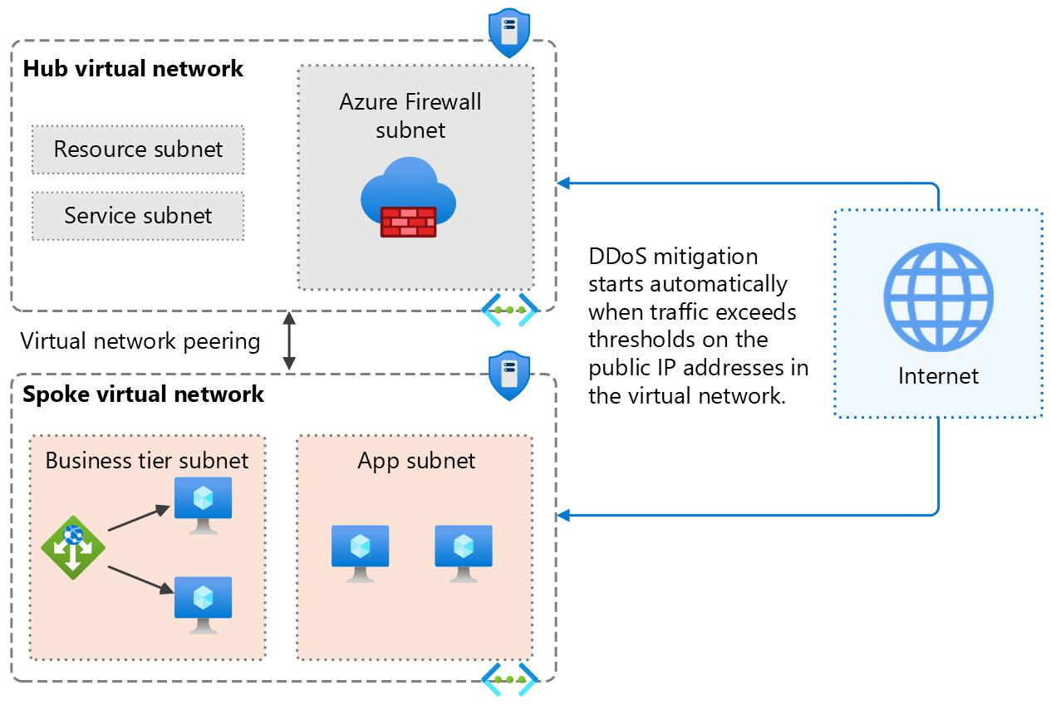
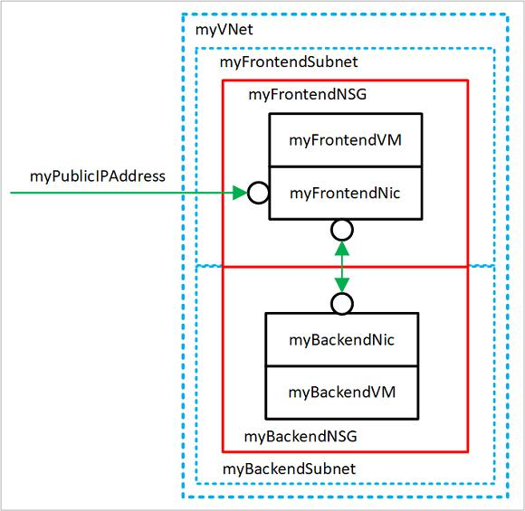
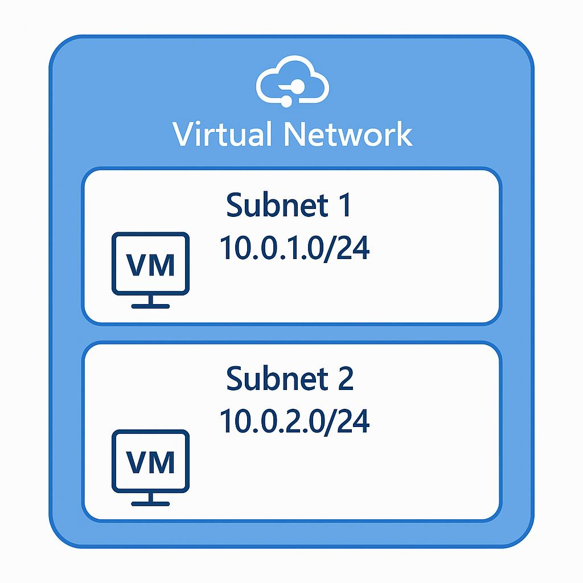

- Overview of Azure Virtual Network (VNet)
- Purpose of VNets in cloud networking
- Concept of subnets within a VNet
- Secure communication between Azure resources

2. Hub-and-Spoke Architecture Overview
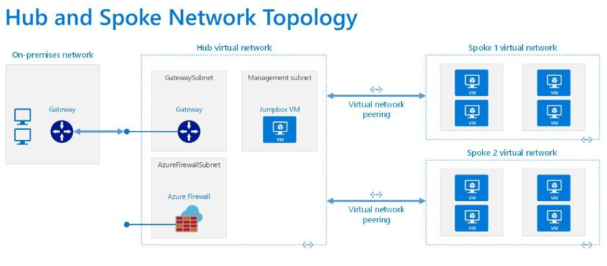
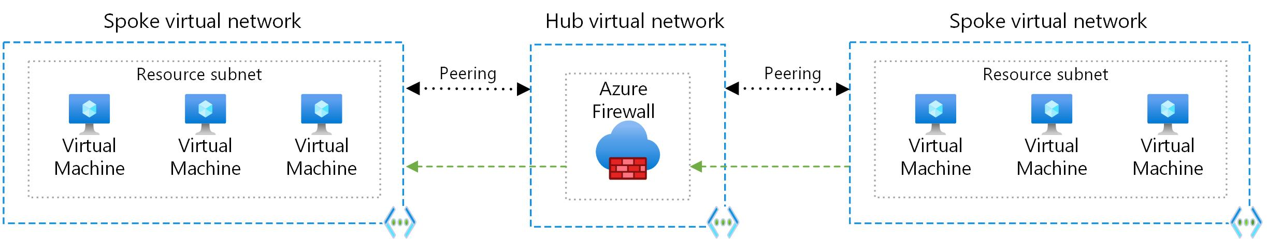
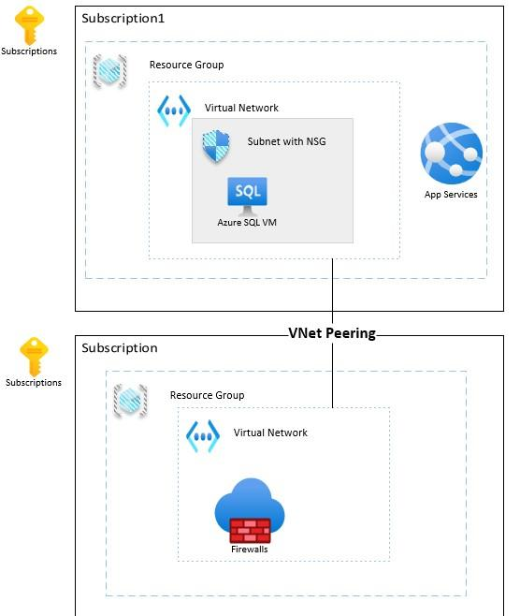
6. Definition of hub-and-spoke network model
- Role of hub-vnet (central control and firewall)
- Role of app-vnet (application hosting)
- Benefits: security, scalability, centralized management

3. Creating the App Virtual Network (app-vnet)
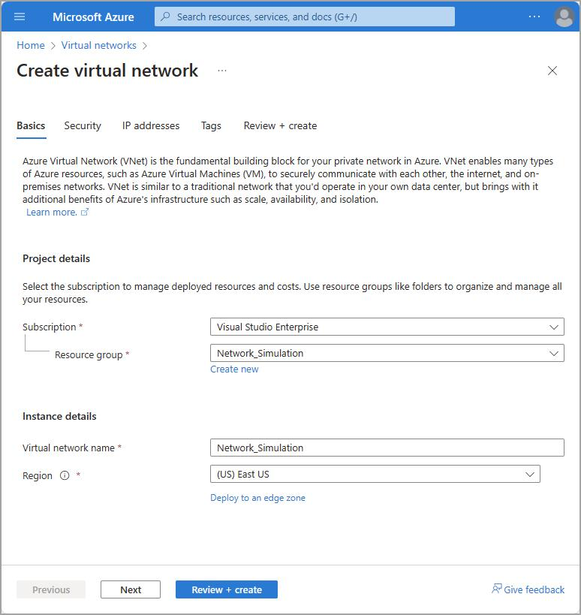
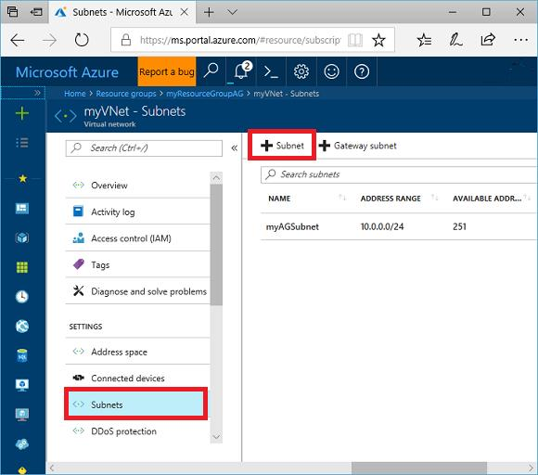
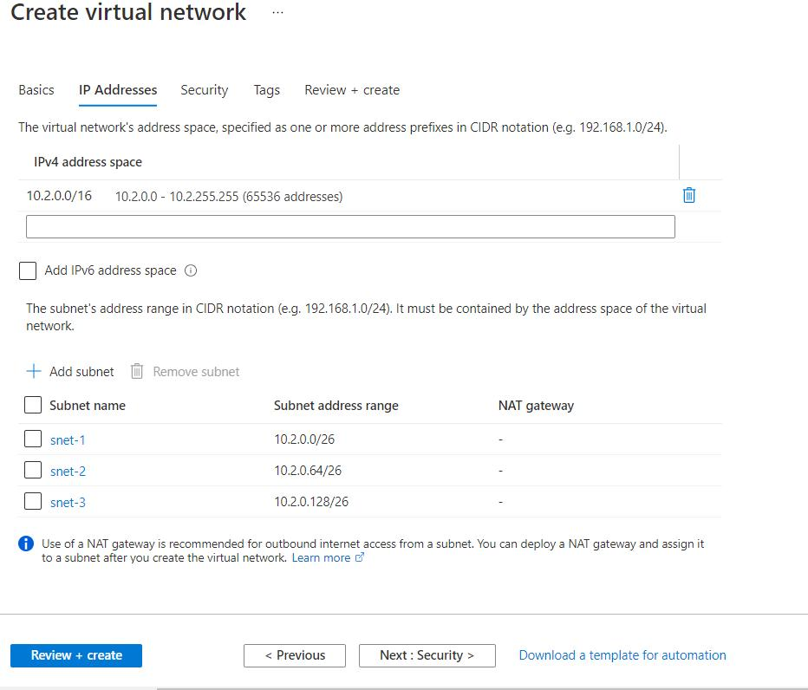
6
- Create app-vnet in Azure Portal
- Resource Group: RG1, Region: East US
- Address space: 10.1.0.0/16
- Subnets:
  - frontend (10.1.0.0/24) – web servers
  - backend (10.1.1.0/24) – database servers

4. Creating the Hub Virtual Network (hub-vnet)
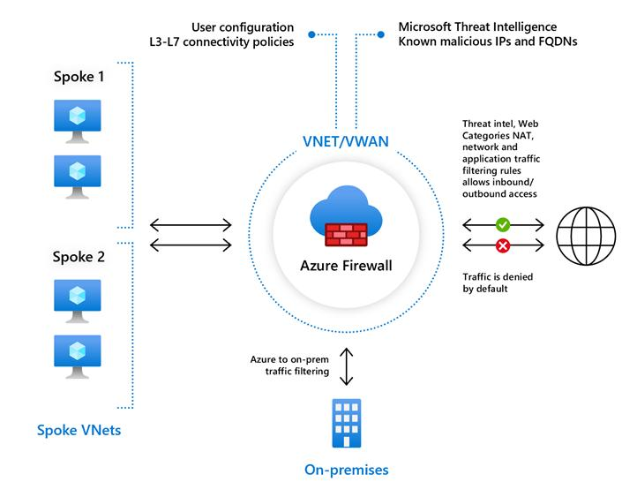
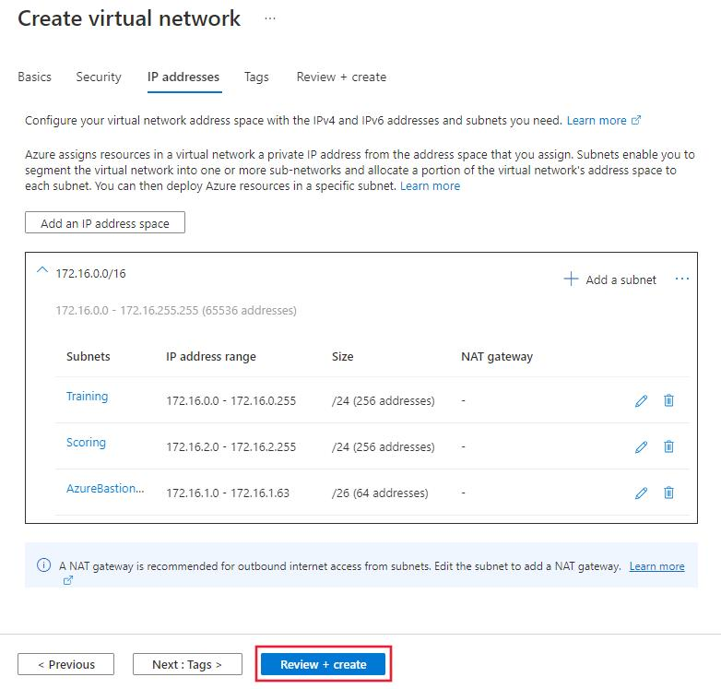
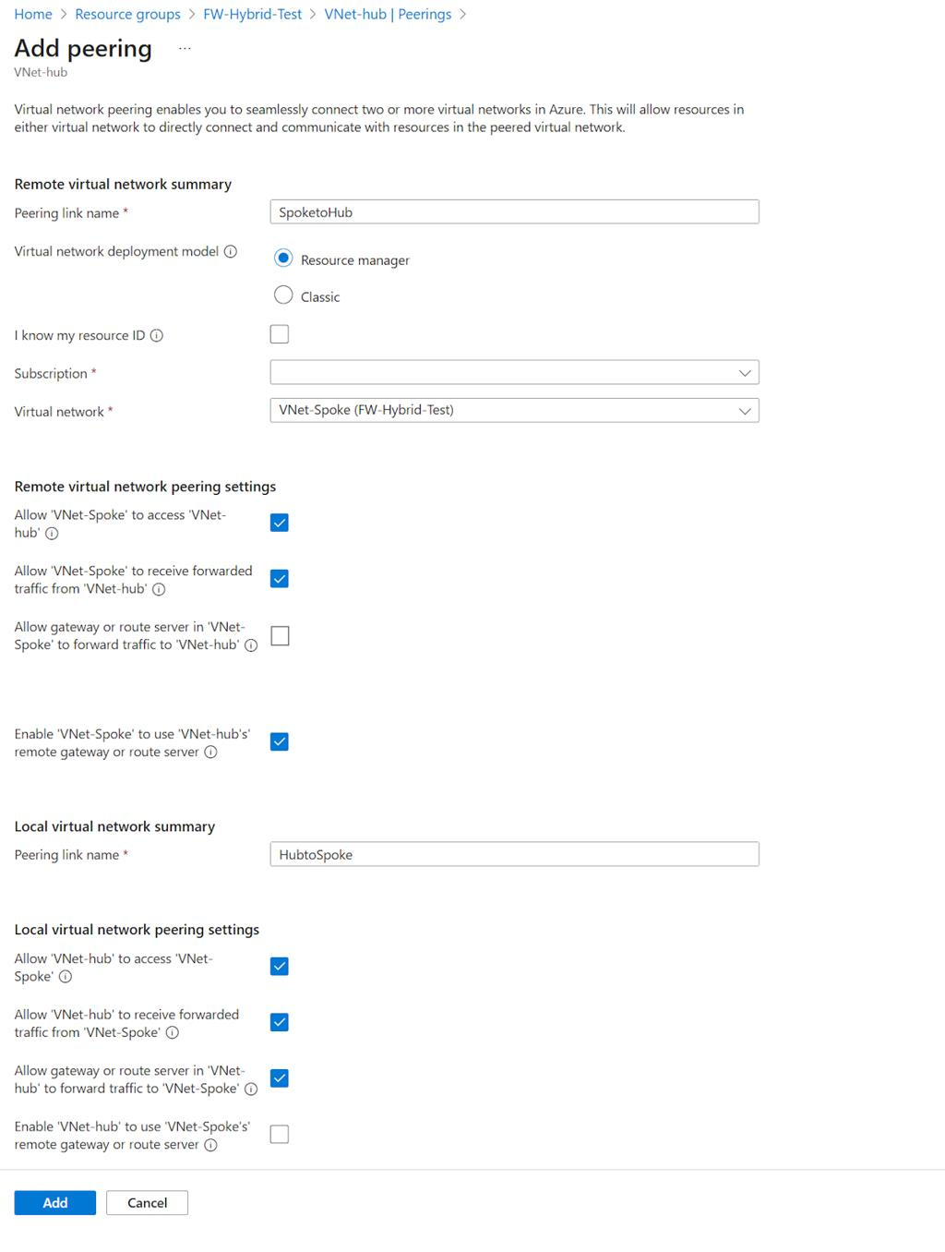
6
- Create hub-vnet in Azure Portal
- Resource Group: RG1, Region: East US
- Address space: 10.0.0.0/16
- Subnet:
  - AzureFirewallSubnet (10.0.0.0/26) – firewall deployment

5. Verifying Virtual Networks and Subnets
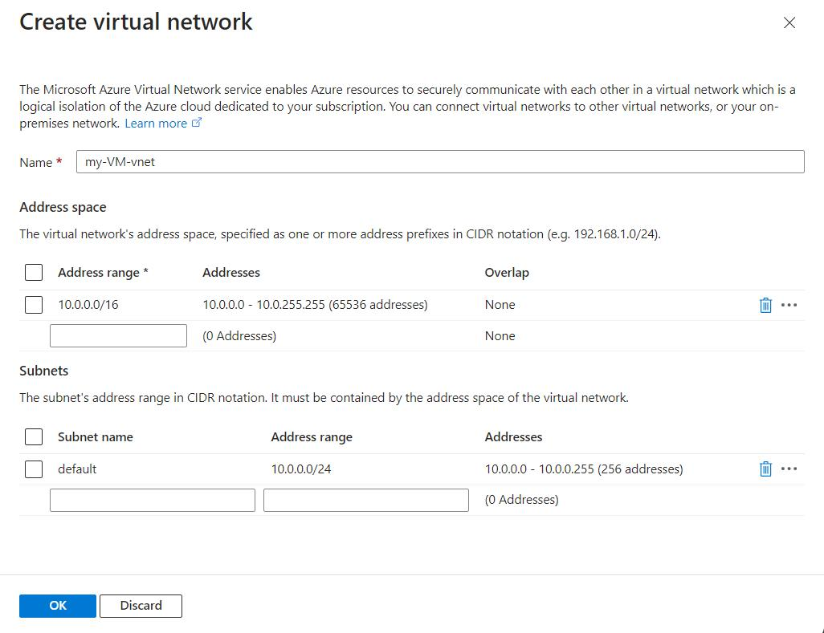
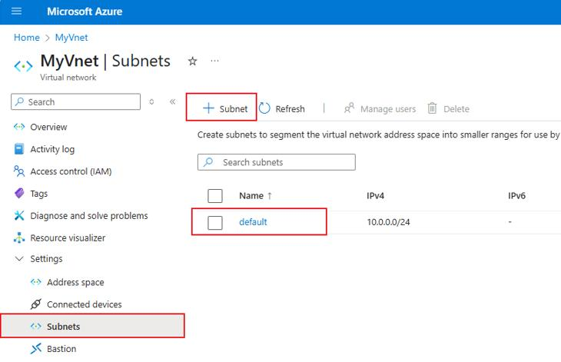
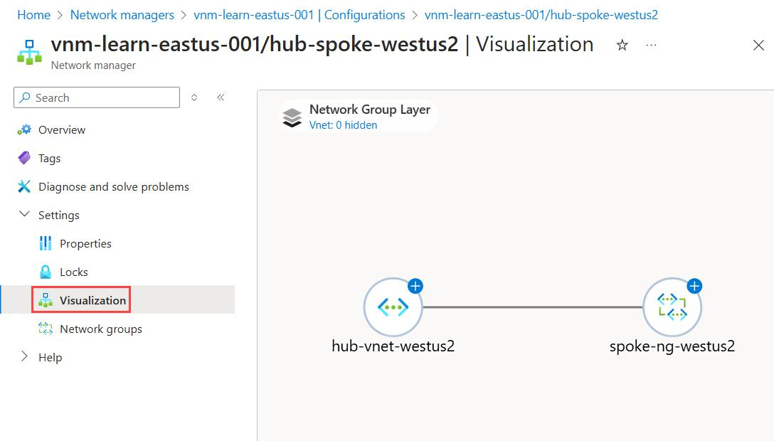
6
- Check both VNets in Azure Portal
- Confirm subnet configurations
- Ensure deployments completed successfully

6. Configuring Virtual Network Peering
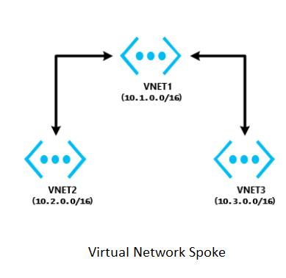
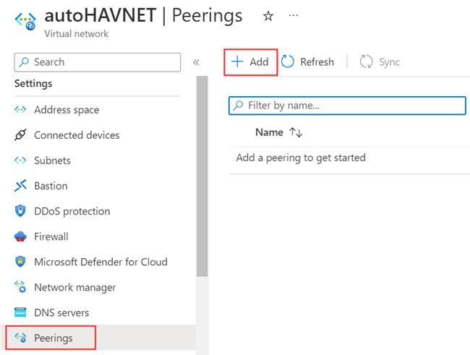
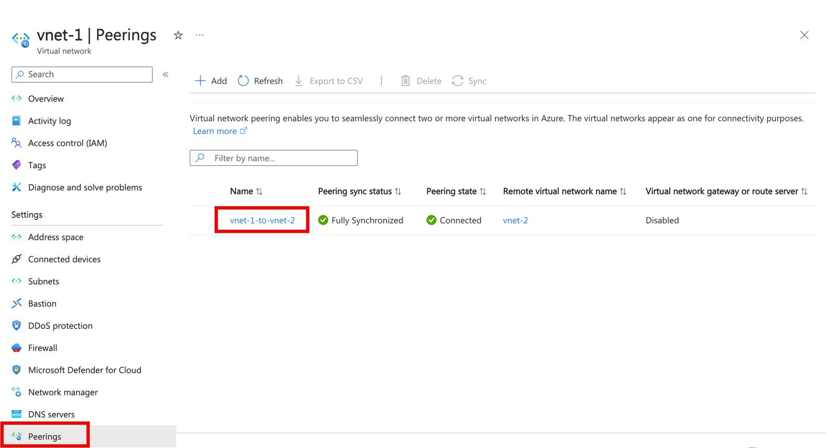
5
- Navigate to app-vnet → Peerings
- Create peering between:
  - app-vnet ↔ hub-vnet
- Configure:
  - app-vnet-to-hub
  - hub-to-app-vnet
- Ensure peering status is Connected
- Note:Leave all other settings as their defaults. When finished select “Review + create and then Create.
- Create the Hub-vnet virtual network configuration. This virtual network has the firewall subnet.
Property | Value
Resource group | RG1
Name | hub-vnet
Region | East US
IPv4 address space | 10.0.0.0/16
Subnet name | AzureFirewallSubnet
Subnet address range | 10.0.0.0/26
- Once the deployments are complete, search for and select your ‘virtual networks`.
- Verify your virtual networks and subnets were deployed.

Configure a peer relationship between the virtual networks
Virtual network peering enables you to seamlessly connect two or more Virtual Networks in Azure.
- Search for and select the app-vnet virtual network.
- In the Settings blade, select Peerings.
- + Add a peering between the two virtual networks.
Property | Value
Remote peering link name | app-vnet-to-hub
Virtual network | hub-vnet
Local virtual network peering link name | hub-to-app-vnet
- Note: Leave all other settings as their defaults. Select “Add” to create the virtual network peering.
- Once the deployment completes, verify the Peering status is Connected.

